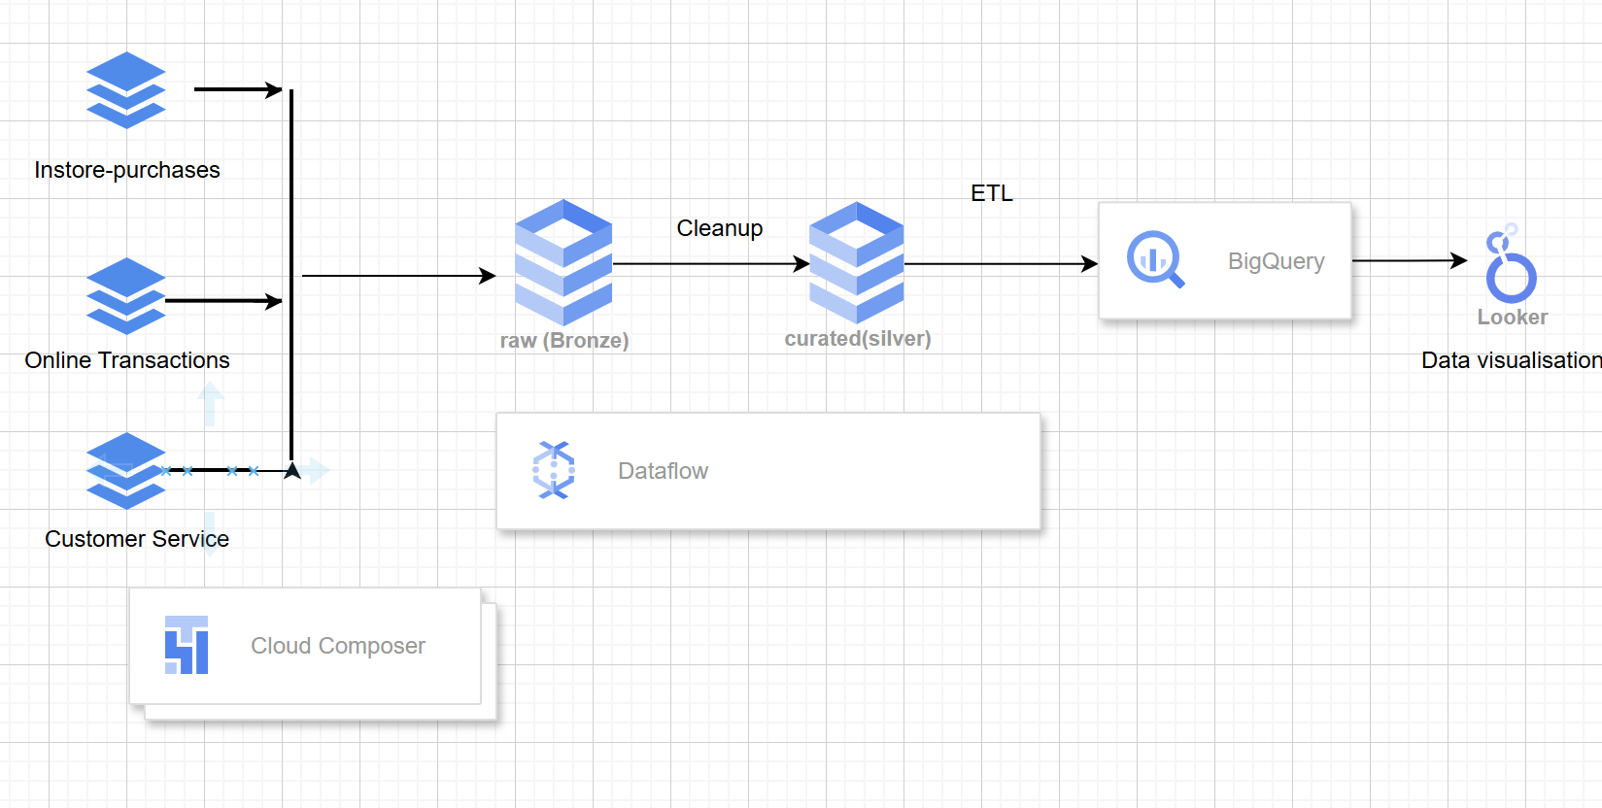

Role:

In this project, I was responsible for transforming pre-cleaned customer data using **Google Cloud Dataflow** and loading it into **BigQuery**. I defined the **staging (silver)** and **analytics (gold)** schemas to structure the data effectively for downstream analysis. Once the data was loaded into BigQuery, I developed **Customer 360 dashboards in Looker Studio** to present key insights such as customer segmentation, order patterns, and service performance.